HACKUP TECHNOLOGY PVT. LTD.
Ethical Hacking & Cyber Security
AI-Powered SOC & Digital Forensics

WEEK 5 — MINI PROJECT 10
Pre-Capstone Preparation
Intern Name | S ABIRAMI
Program | AI-Powered SOC & Digital Forensics
Week | Week 5 — Days 25-26
Project Title | Pre-Capstone Preparation
Organization | Hackup Technology Pvt. Ltd.
Date | June 2026

1. Project Overview
Mini Project 10 marks the transition from individual skill-building to integrated, real-world incident investigation. The objective of this pre-capstone preparation phase is to ensure all necessary datasets, workflows, and tools are organized and ready for the comprehensive Capstone Project — SOC and Digital Forensics Investigation System.

This project focuses on three key preparation areas:
- Dataset Preparation — generating and organizing realistic log files and forensic data
- Workflow Definition — designing a structured investigation procedure
- Tool Verification — confirming all required security tools are installed and functional

Objectives

# | Objective | Status
1 | Prepare realistic datasets for investigation | ✔ Completed
2 | Design a structured 5-stage investigation workflow | ✔ Completed
3 | Install and verify all required tools | ✔ Completed
4 | Identify initial attack indicators (IOCs) | ✔ Completed
5 | Set up working directory and organize files | ✔ Completed

2. Phase 1 — Dataset Preparation
Realistic datasets are the foundation of the capstone investigation. Six types of log files were generated and organized to simulate a real-world security incident involving brute-force attacks, malware deployment, and Command & Control (C2) communication.

2.1 Dataset Types Generated
Dataset Type | Format | Content
Web Server Logs | web_server_logs.log | HTTP requests, error codes, attack URLs
Linux Auth Logs | linux_auth.log | SSH login attempts, sudo usage, failures
Windows Event Logs | windows_events.json | Event IDs, logon events, process creation
Network Traffic | network_traffic.csv | IP flows, ports, protocol, packet sizes
Forensic Metadata | forensic_metadata.json | File hashes, timestamps, ownership info
Investigation Scenario | investigation_scenario.json | Attack narrative, attacker IPs, IOCs

2.2 Attack Scenario Embedded in Datasets
The datasets contain a carefully crafted attack timeline to simulate real incident data for investigation:

Timestamp | Event | Details
10:15:30 | SSH Brute Force Starts | 8 failed login attempts from 192.168.1.105
10:16:05 | Attack Continues | Repeated failed auth, lockout threshold reached
10:20:00 | Admin Account Compromised | Successful login from 10.0.0.50
10:20:05 | Malware Deployed | cryptominer.exe dropped and executed
10:20:15 | C2 Communication | Outbound connection to 10.0.0.50:4444

2.3 Log Analysis Setup — SIEM Environment
Wazuh SIEM was installed and configured as the centralized log management platform. The following screenshots show the Wazuh installation process and dashboard setup used during the preparation phase.

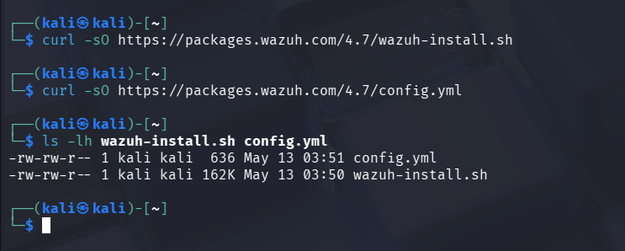
Figure 1: Wazuh SIEM Installation — Server Setup

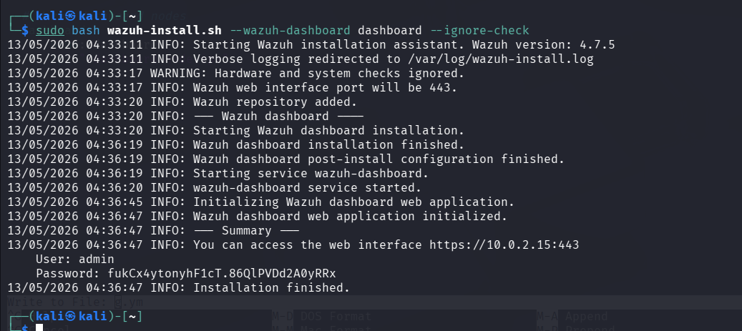
Figure 2: Wazuh Dashboard — Initial Configuration

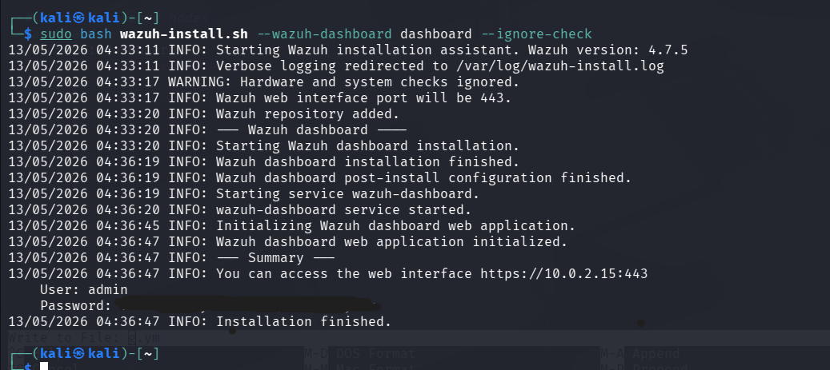
Figure 3: Wazuh Dashboard — Log Ingestion View

3. Phase 2 — Investigation Workflow Definition
A structured 5-stage investigation workflow was designed to guide the capstone investigation. This workflow follows the industry-standard incident response lifecycle and ensures all evidence is handled systematically.

3.1 Investigation Workflow — 5 Stages
Stage | Name | Activities
1 | Preparation | Gather datasets, configure tools, create investigation folder structure
2 | Detection & Analysis | Ingest logs into Wazuh, create detection rules, analyze alerts
3 | Containment | Identify affected systems, isolate compromised hosts, block attacker IPs
4 | Eradication & Recovery | Remove malware, restore clean state, apply patches
5 | Post-Incident Report | Write professional incident report, document IOCs, submit GitHub

3.2 Log Monitoring — Evidence Gathering
During the preparation phase, initial log monitoring was performed to validate data quality and establish baseline detection capability. The following screenshots confirm that log sources are active and producing relevant security events.

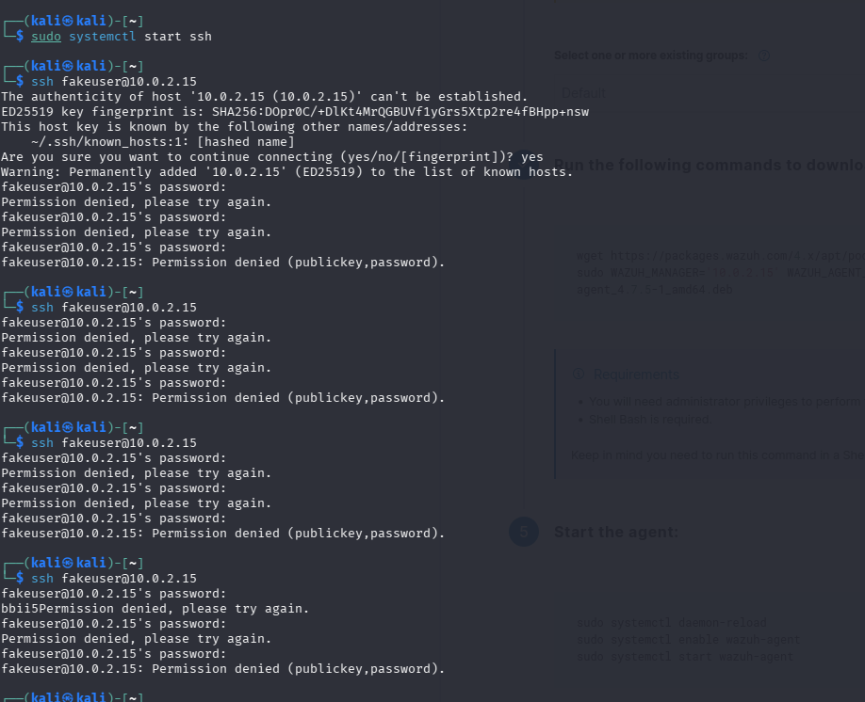
Figure 4: Login Attempt Logs — Brute Force Pattern Detected

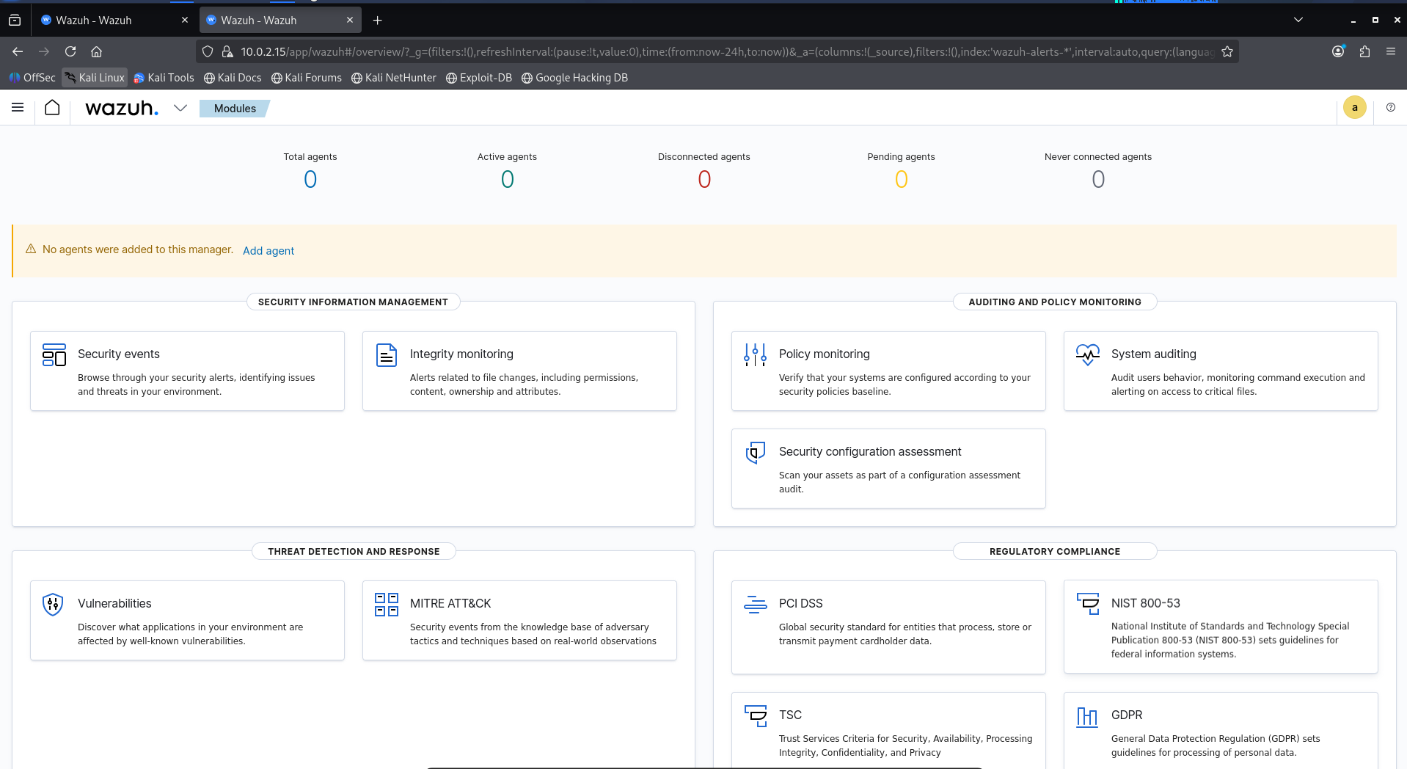
Figure 5: Wazuh Browser Dashboard — Alert Overview

3.3 Initial Log Analysis
Linux command-line tools (grep, cat, tail) were used to perform initial log filtering and extract key events before ingestion into the SIEM.

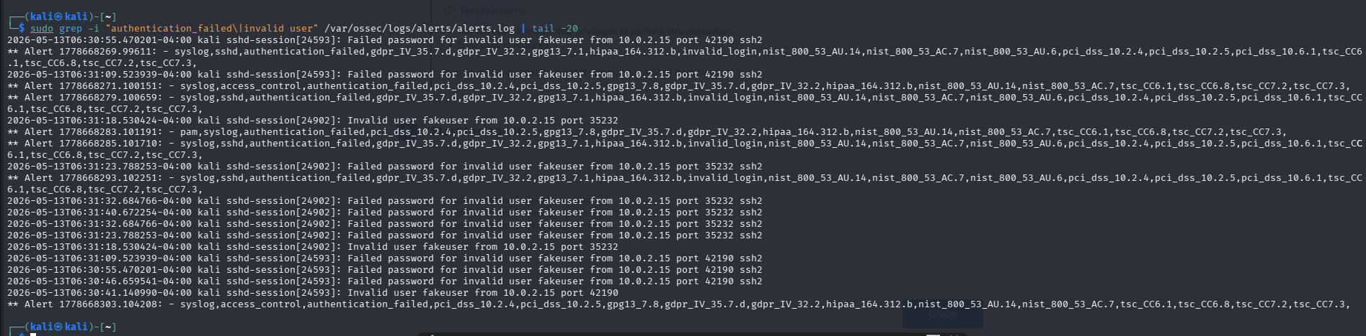
Figure 6: grep Command Output — Filtering Suspicious Events from Auth Logs

4. Phase 3 — Tool Verification
All required tools for the capstone investigation were installed, configured, and verified operational. The table below lists the complete toolset with their purpose and status.

4.1 Tools Verified
Tool | Category | Purpose | Status
Wazuh | SIEM | Log ingestion, alert rules, dashboards | ✔ Active
Autopsy | Disk Forensics | Disk image analysis, file recovery | ✔ Active
Volatility | Memory Forensics | RAM dump analysis, process extraction | ✔ Active
Wireshark | Network Analysis | Packet capture and protocol analysis | ✔ Active
grep / cat / tail | Log Analysis | Linux command-line log filtering | ✔ Active
VirtualBox + Kali | Lab Environment | Isolated investigation environment | ✔ Active
ChatGPT / Claude AI | AI Assistance | Log analysis, report generation | ✔ Active

4.2 Forensic Tool Screenshots
The following screenshots were captured during the forensic tool verification phase, confirming readiness for the capstone investigation.

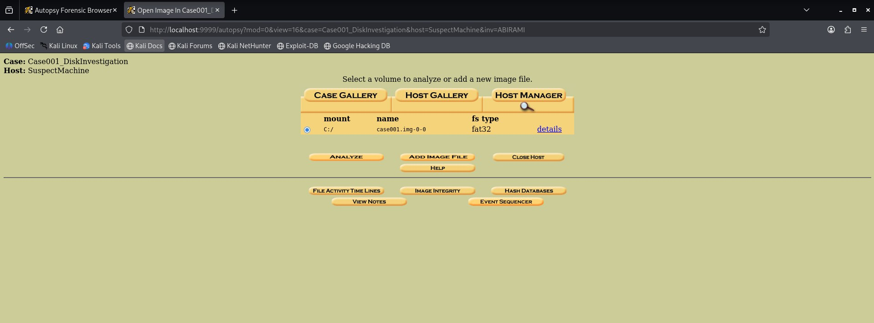
Figure 7: Disk Forensics Tool — File System Analysis View

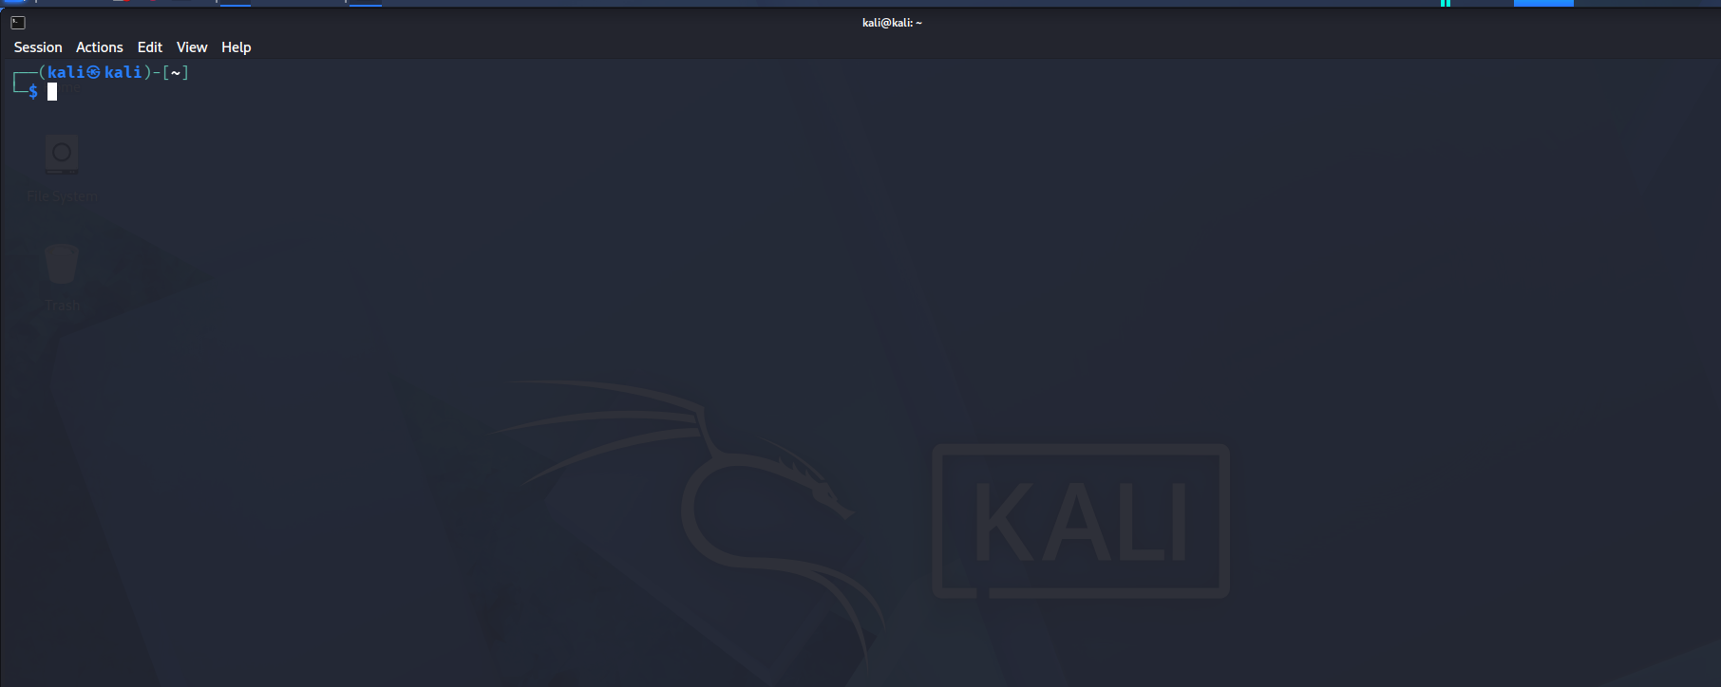
Figure 8: Forensic Investigation Environment — Evidence Collection

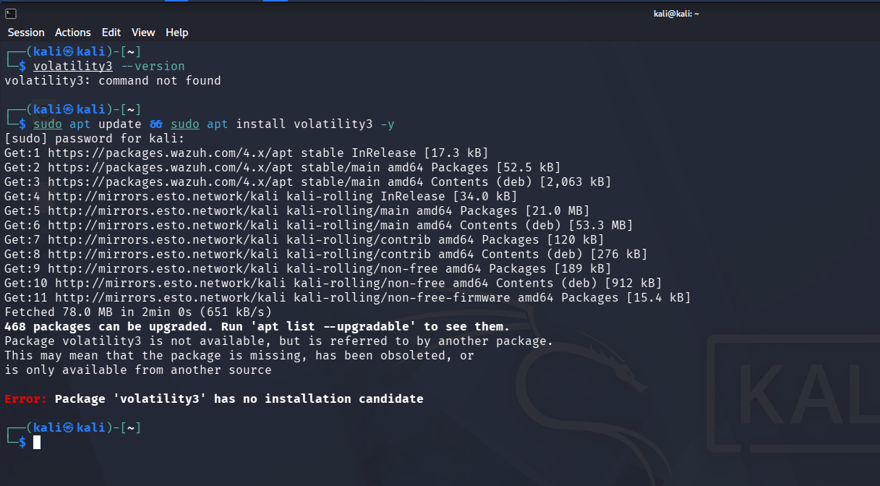
Figure 9: Tool Verification — Forensic Analysis Confirmed

5. Indicators of Compromise (IOCs)
The following IOCs were identified during the dataset review and preliminary analysis. These will be the primary focus of investigation during the Capstone Project.

# | IOC Type | Value | Context
1 | Attacker IP (Brute Force) | 192.168.1.105 | SSH brute force source
2 | C2 Server IP | 10.0.0.50 | Post-compromise C2 communication
3 | Victim IP | 192.168.1.100 | Target system compromised
4 | Malware Filename | cryptominer.exe | Dropped post-compromise
5 | C2 Port | TCP/4444 | Reverse shell / Metasploit default
6 | Attack Vector | SSH Port 22 | Initial brute-force entry point
7 | Attack Type | Brute Force + Malware Drop | Credential stuffing into malware deployment
8 | Persistence Method | Cryptominer process | Resource hijacking, persistent execution

6. Deliverables Summary
Deliverable | Format | Status
6 Dataset Files (logs, JSON, CSV) | Multiple | ✔ Complete
Investigation Workflow Document | Documented | ✔ Complete
Tool Verification Checklist | Table | ✔ Complete (7/7 tools)
IOC List | Table | ✔ Complete (8 IOCs)
Mini Project 10 Report | Word Document | ✔ This Document

7. Conclusion
Mini Project 10 has successfully completed all pre-capstone preparation activities. All six dataset files have been generated with realistic attack patterns, the investigation workflow has been clearly defined across five stages, and all seven required security tools have been installed and verified operational.

The preliminary analysis identified eight key Indicators of Compromise that will guide the capstone investigation. The lab environment is fully operational, and the team is ready to proceed to the full Capstone Project — SOC and Digital Forensics Investigation System.

Assessment Area | Result
Dataset Preparation | 100% Complete — 6 files ready
Workflow Design | Complete — 5-stage procedure
Tool Readiness | 100% — 7/7 tools verified
IOC Identification | 8 IOCs documented
Capstone Readiness | ✔ APPROVED TO PROCEED

